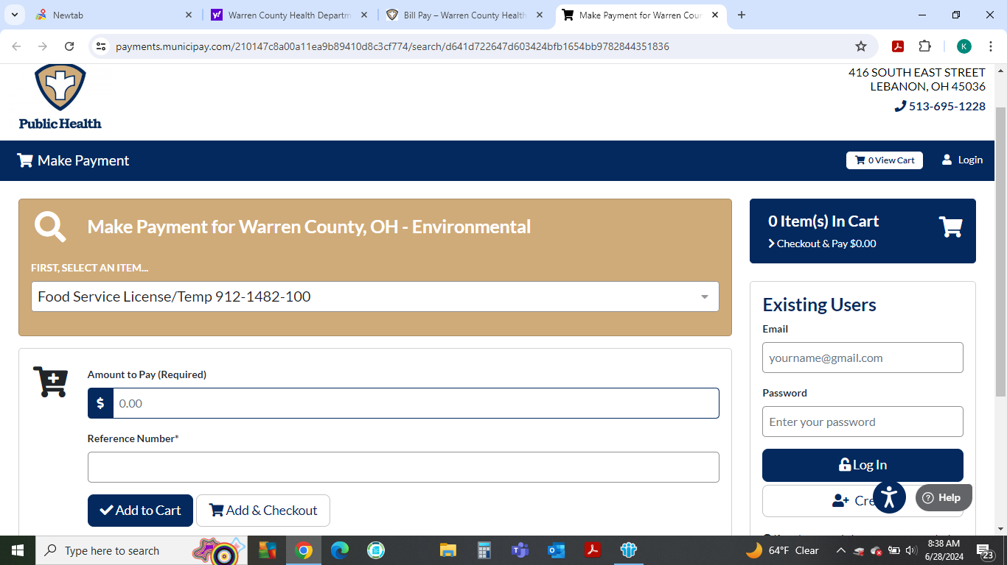

Please see my online guidance below:

http://[www.warrenchd.com](http://www.warrenchd.com)

Bill Pay

Make Payment

Select Payment Item

•        Food Service License/Temp 912-1482-100

Reference #: Type name of temporary food facility

If you are paying for more than one temporary please type: Temp 2-then name of facility.

Payment Amount: $60.00 per application (Commercial-for Profit)

$30.00 (Non-Commercial-non-profit 501c3)

Once you have received your receipt for payment, please forward that to me [kcooper@wcchd.com](mailto:kcooper@wcchd.com) that way I know you have paid.  I will then sign off on your application and we will either mail your permit or if there is not enough time to mail, we will hand deliver to you at the event. Note: Larger Events, we typically hand deliver your permit to you at the event. Kind regards, Kathleen